CAPSTONE PROJECT WEEKLY ACCOMPLISHMENT REPORT

Team Name: COREX Section: BSIT-3A Date: February 2-6
Project Title: Prime Connect: Smart Management and Growth Platform

Accomplishment for the Week

Task / Activity | Description of Work Done | Output / Evidence
Preparation of Capstone  Adviser Acceptance Form | Securing the signature of the capstone adviser. | 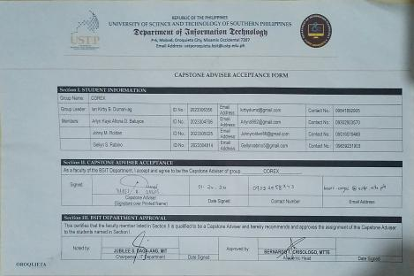
Conduct Group Meeting | The team conduct a group meeting to finalized the system overview and assigning their roles. | 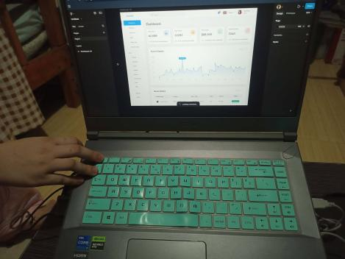
Identification of Unique Features | The group has finalized the unique features that will ensure the proposed system is both highly distinctive and more effective than existing platforms | 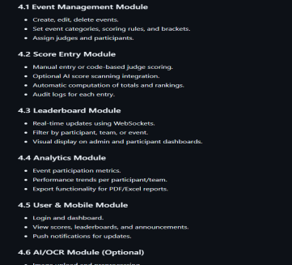

Individual Contribution

Team Member | Contribution
Gellyn S. Rabino | Documenter
Arlyn Kaye Allona D. Baluyos | Quality Assurance
Johny M. Roldan | Data / Analysis Specialist
Ian Kirby B. Duman-ag | Project Manager / Team Leader

Issues Encountered and Actions Taken

Issue/Concern | Action Taken / Resolution
Limited Time for discussion | Conduct another schedule for a group discussion
Difficulty when identifying the unique features | Research more for a unique features

Plan for the Next Week

Planned Task | Expected Output
Preparing for concept proposal, concept paper, pitch deck. | The completed and finalized concept paper,pitch deck ready for submission.

Adviser’s Remarks

Reviewed by:

Mr. Hanes A. Ongos
Capstone Project Adviser
Date Signed:

Note:

- This report shall be submitted weekly to the Capstone Adviser.
- All members must actively contribute and be reflected in the report.
- Supporting evidence (screenshots, documents, commitments, etc.) may be attached.
- Submission of this report forms part of the progress monitoring and individual assessment of the Capstone Project.

